12.87: a) There are many ways of approaching this problem; two will be given here.
I) Denote the orbit radius as and the distance from this radius to either ear as . Each ear, of mass , can be modeled as subject to two forces, the gravitational force from the black hole and the tension force (actually the force from the body tissues), denoted by 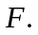 Then, the force equations for the two ears are
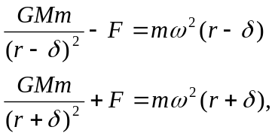

where is the common angular frequency. The first equation reflects the fact that one ear is closer to the black hole, is subject to a larger gravitational force, has a smaller acceleration, and needs the forceto keep it in the circle of radius 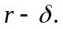 The second equation reflects the fact that the outer ear is further from the black hole and is moving in a circle of larger radius and needs the force to keep in in the circle of radius 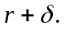
Dividing the first equation by 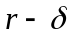 and the second by 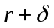 and equating the resulting expressions eliminates , and after a good deal of algebra,
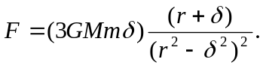
At this point it is prudent to neglect in the sum and difference, but recognize that is proportional to , and numerically 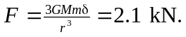 (Using the result of Exercise 12.39 to express the gravitational force in terms of the Schwartzschild radius gives the same result to two figures.)
II) Using the same notation,
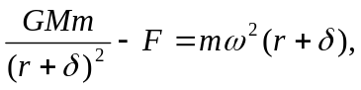
where can be of either sign. Replace the product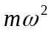with the value for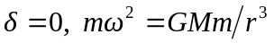 and solve for
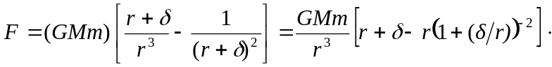
Using the binomial theorem to expand the term in square brackets in powers of 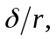
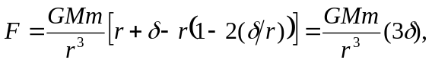
the same result as above.
Method (I) avoids using the binomial theorem or Taylor series expansions; the approximations are made only when numerical values are inserted and higher powers of are found to be numerically insignificant.
Method (II) uses the fact even though the center of gravity is not at the center of mass, their separation is small compared to r, and so the period of the orbit of a point mass at that position can be used to characterize the motion.
If noninertial frames are allowed, the same result may be obtained by considering the frame of the astronaut; the difference in the position of the ears contributes a difference between the gravitational forces of magnitude 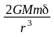 and the fact that the astronaut is in a frame that rotates with frequency as found above means that in her frame the ears need an extra force of 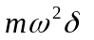, and the tension is the same. (This method was suggested by a first-year MIT undergraduate.)
This tension is much larger than that which could be sustained by human tissue, and the astronaut is in trouble. b) See the discussion above; the center of gravity is not the center of mass.

